EnterAct Project Plan Draft

The Software Alchemists

Team Members: Masud, Joel, Gray

Date:2/14/2024

Table of Contents

Introducion………………………………………………………………………………………...3

**Scope and Purpose of document**………..……………………………………...………..3

System Scope……………………………………………………………………………………...3

**Problem/Opportunity description**………………………………………………………3

**Anticipated Business/Personal Benefits**………………………………………………...3

**System Capabilities**……………..………………………………………………………..3

**System Context**…………………………………………………………………………...4

Schedule…………………………………………………………………………………………...4

Staff Organization…………………………………………………………………………………4

**Team Structure**…………………………………………………………………………...4

Tracking And Control Mechanisms……………………………………………………………….4

Introduction

**Scope and Purpose of Document (JP)**

Introducing EnterAct, an innovative app designed to revolutionize the way we engage with entertainment and leisure activities. This document is made to highlight and map out where we currently are in the vision of creating this application and where we hope to bring that idea in the future. EnterAct is an application designed to bridge the gap between users and creators in an innovative manner, enhancing the experience of self-promotion for content creators. Whether it's discovering emerging artists, following top streamers, or exploring niche content creators, EnterAct revolutionizes the way users connect with the creators they love, making it easier than ever to stay engaged and entertained. And with a creator personalized store, picking up a creator's exclusive merchandise will be far easier than ever.

System Scope

**Problem/Opportunity Description (JP)**

The goal of EnterAct is to address the fragmentation and inefficiencies in the entertainment industry by providing a unified platform that connects users and creators seamlessly. Traditional methods of discovering and engaging with content creators are often disjointed, with users having to navigate multiple platforms and channels to find their favorite creators and their content. Additionally, creators face challenges in self-promotion and monetization, struggling to reach and retain their audience effectively. EnterAct seeks to solve these problems by offering users a streamlined experience for discovering and following their favorite creators, while empowering creators with tools for self-advertising and monetization. By providing a centralized hub for entertainment consumption and creator interaction, EnterAct aims to capitalize on the growing demand for personalized and engaging content experiences in the digital age.

**Anticipated Business/Personal Benefits (JP)**

EnterAct aims to become the premier platform for users to seamlessly engage with entertainment and creators. Utilizing a unique blogging and mercantile structure we can hope to create wonderful monetary value for creative users and facilitate trade ease of access. For users, EnterAct offers a seamless way to connect with entertainment and creators.

**System Capabilities**

* Streamlined user registration and profile creation

1. Utilizing Multiple account type registration. Users can sign up as either a creator, normal user, or privileged user.

* Content discovery through personalized recommendations

1. Using a follower system and stated preferences, users and creators are given access to new content that is aligned with their own searches and creators.
2. Following creators gives access to quests and other neat ways to interact including commenting and chatting in blog posts.

* Accessing creator-exclusive content and merchandise

1. Each creator has access to a customizable store full of links and images for purchase
2. Utilizing this creators can gain self-monetization in all new ways.

**System Context (M)**

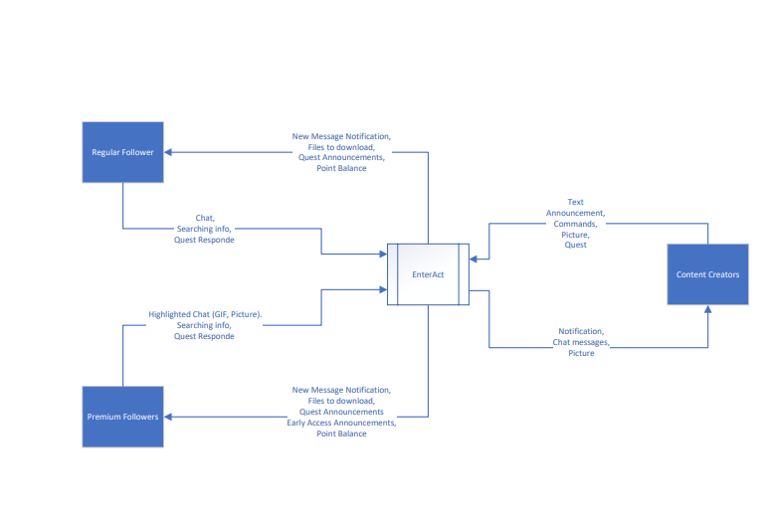

Schedule **(M)**

Included in project files

Under

Staff Organization**(JP)**

* Project manager: Joel
* Project coordinator: Masud
* Team member: Gray

Tracking and Control Mechanisms**(JP)**

The Software alchemists keeps track of progress by regularly updating the Trello board every week with tasks and constantly keeps up-to-date on personal chats about our progress and assignments. Using the Github and document sharing we keep all of our project assignments up-to-date.